/*

**Problem 1:**

Display first and last name, hire_date, and salary for employees hired before January 1,1994, or having a salary greater

than 10000. Order the resulting data set by salary in descending order and hire_date in ascending order.

*/

SELECT first_name, last_name, hire_date, salary

FROM employees

WHERE hire_date < '1-JAN-1994' OR salary >10000

ORDER BY salary DESC, hire_date;

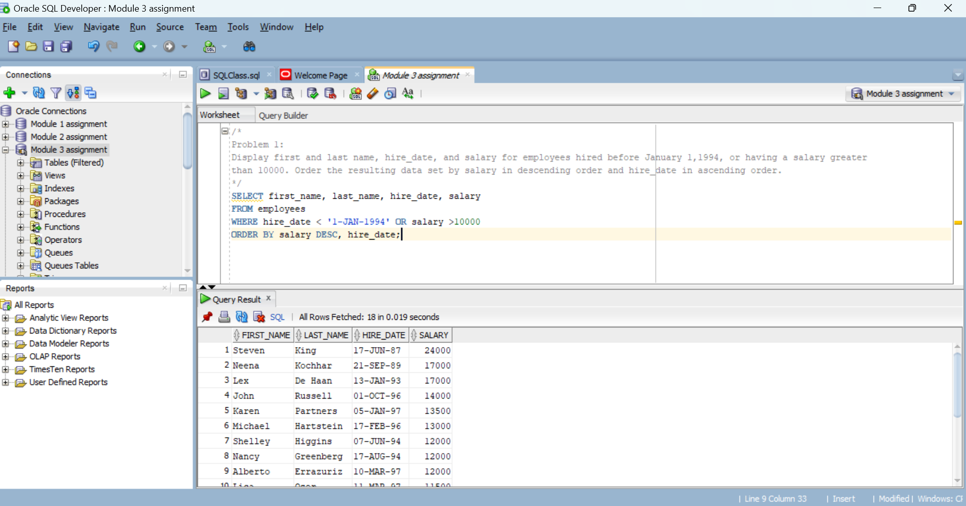

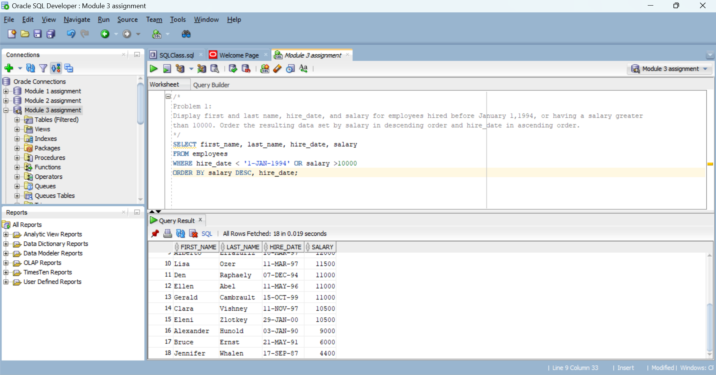

/*

**Problem 2:**

Display location_id city, state_province, and the following derived column from table locations:

Extract the street name from the street_address column (= removing the street number) and alias it as street.

Make sure to remove any leading or trailing blank spaces.

Filter the data for location_id values 1500, 1700, 1800, and 1900. Order the resulting data set by city in ascending order.

Issue the following command before executing the query to reduce the formatted length of column street:

COLUMN street FORMAT a20

*/

SELECT location_id, city, state_province,

Trim(Substr(street_address,Instr(street_address, ' ',1)+1)) AS "street"

FROM locations

Where location_id IN (1500, 1700, 1800, 1900)

ORDER BY city;

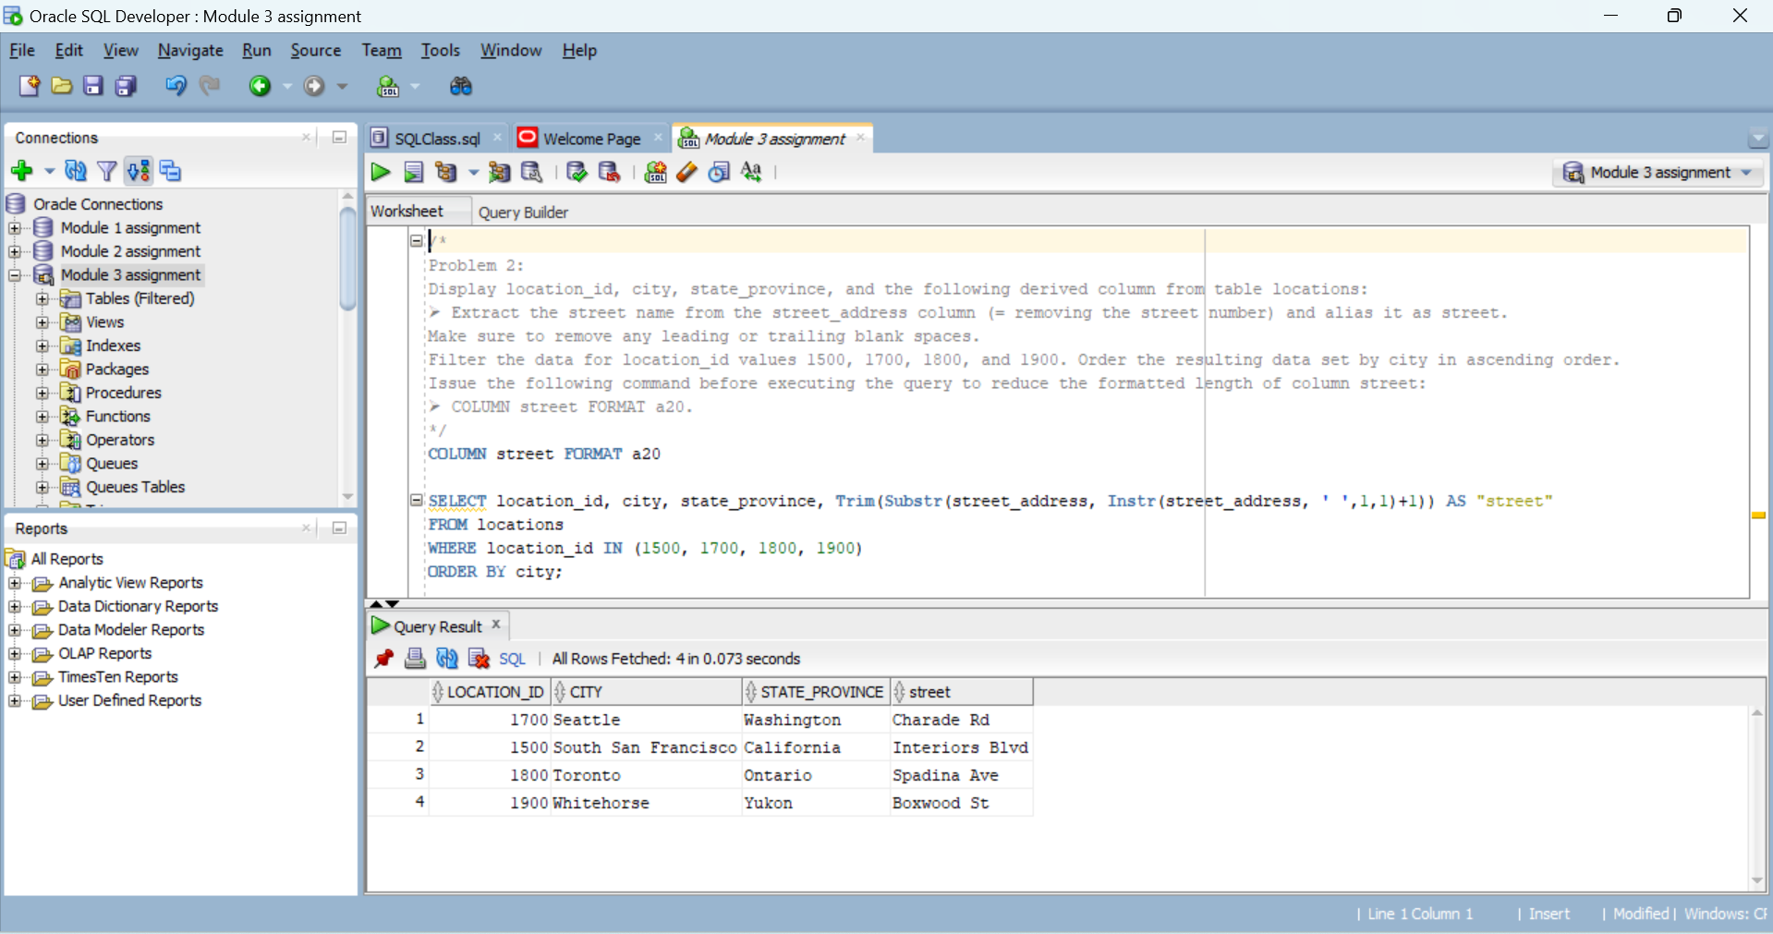

/*

**Problem 3:**

Display first_name, last_name, hire_date, job_id and salary for job_id values starting with SA and having a salary equal

to or greater than 10000. Order the resulting data set by salary and hire_date in ascending order.

*/

SELECT first_name, last_name, hire_date, job_id, salary

FROM employees

Where job_id LIKE 'SA%' AND salary >= 10000

ORDER BY salary, hire_date;

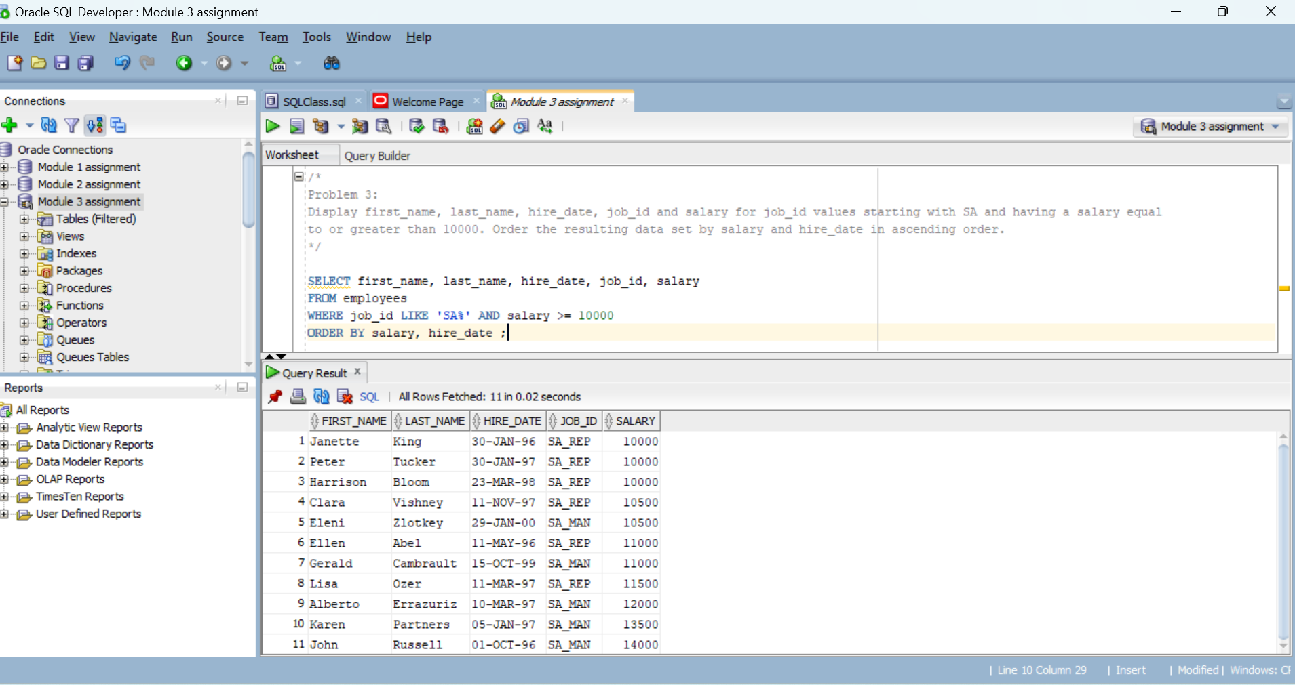

The other solution using Substr function:

SELECT first_name, last_name, hire_date, job_id, salary

FROM employees

Where Substr(job_id,1,2) = 'SA' AND salary >= 10000

ORDER BY salary, hire_date;

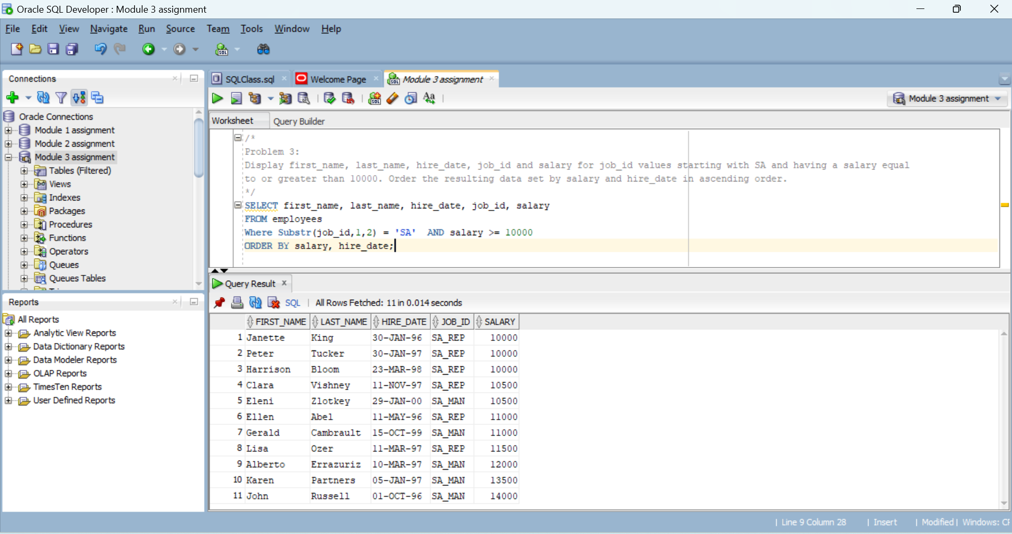

/*

**Problem 4:**

Display first_name, last_name, salary and hire_date for employees having a salary of equal to or greater than 10000.

Create an additional column which displays the string ‘Before 2000’ for hire_date values before January 1st, 2000 and

‘On or after 2000’ for all other values. Use a column alias of Hire_Date_Century. Order the resulting data set by the

same column expression (Hire_Date_Century) in descending order, last_name and first_name both in ascending order.

*/

SELECT first_name, last_name, hire_date, job_id, salary,

CASE

When hire_date < '1-Jan-2000' then 'Befor 2000'

Else 'On or after 2000'

END AS "Hire_Date_Century"

FROM employees

WHERE salary >= 10000

ORDER BY "Hire_Date_Century" DESC, last_name, first_name ;

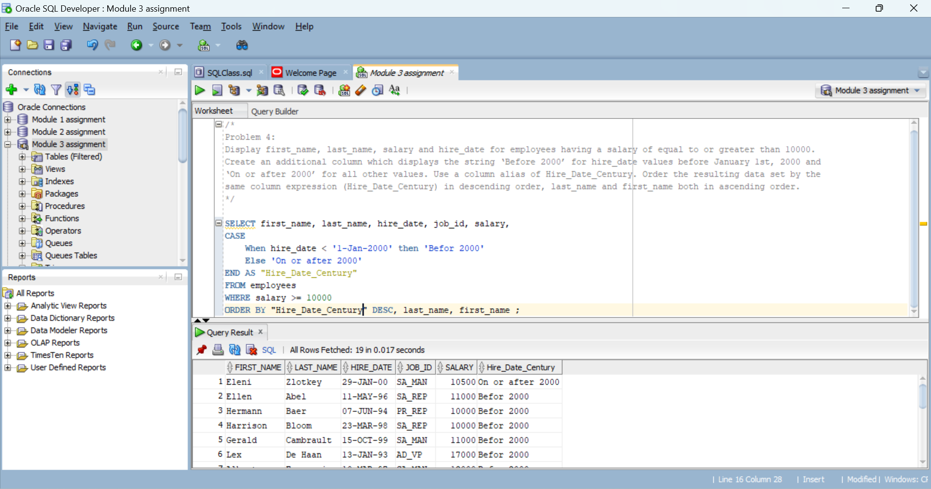

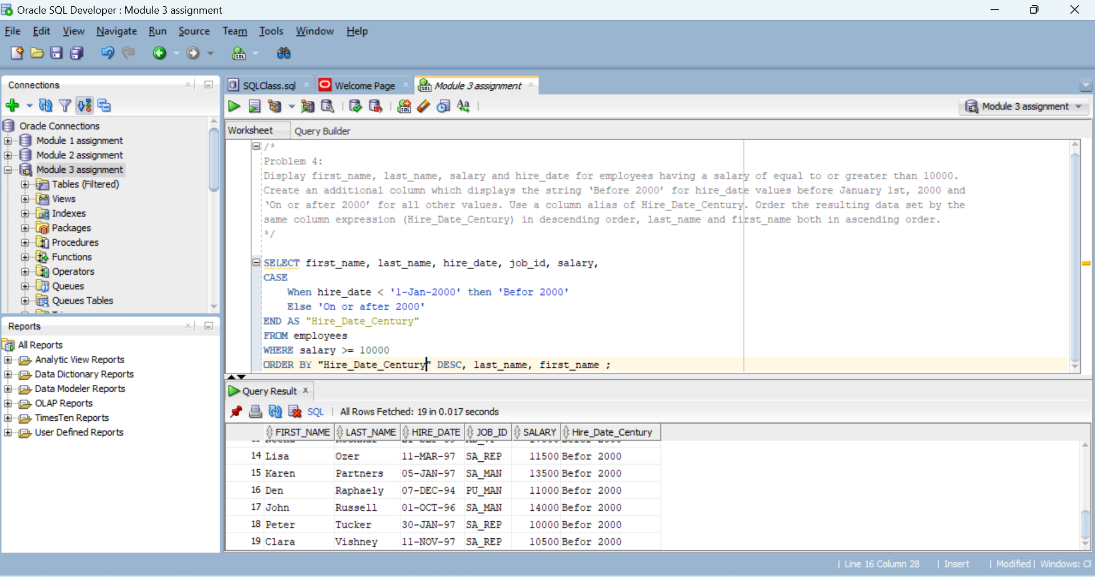

/*

**Problem 5:**

Display last_name, salary, department_id and commission_pct and order the resulting data set by department_id and

last_name. Create an additional column for giving employees an additional bonus: Employees will receive a certain

percentage of their salary as a bonus: This percentage is 10% of their commission_pct value, for those employees having

no commission_pct use 1%. Alias this column Addtl_Bonus. Display the resulting data set only for department_id values

of 20 and 80 and for last_name starting with A or F or H or S.

*/

SELECT last_name, salary, department_id, commission_pct,

salary*0.1*NVL(commission_pct, 0.01) AS "Addtl_Bonus"

FROM employees

WHERE department_id IN (20, 80) AND Substr(last_name, 1, 1) IN ('A', 'F', 'H', 'S')

ORDER BY department_id, last_name ;

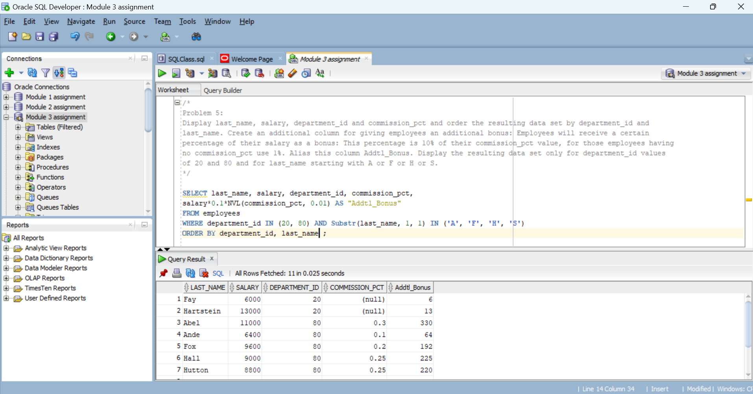

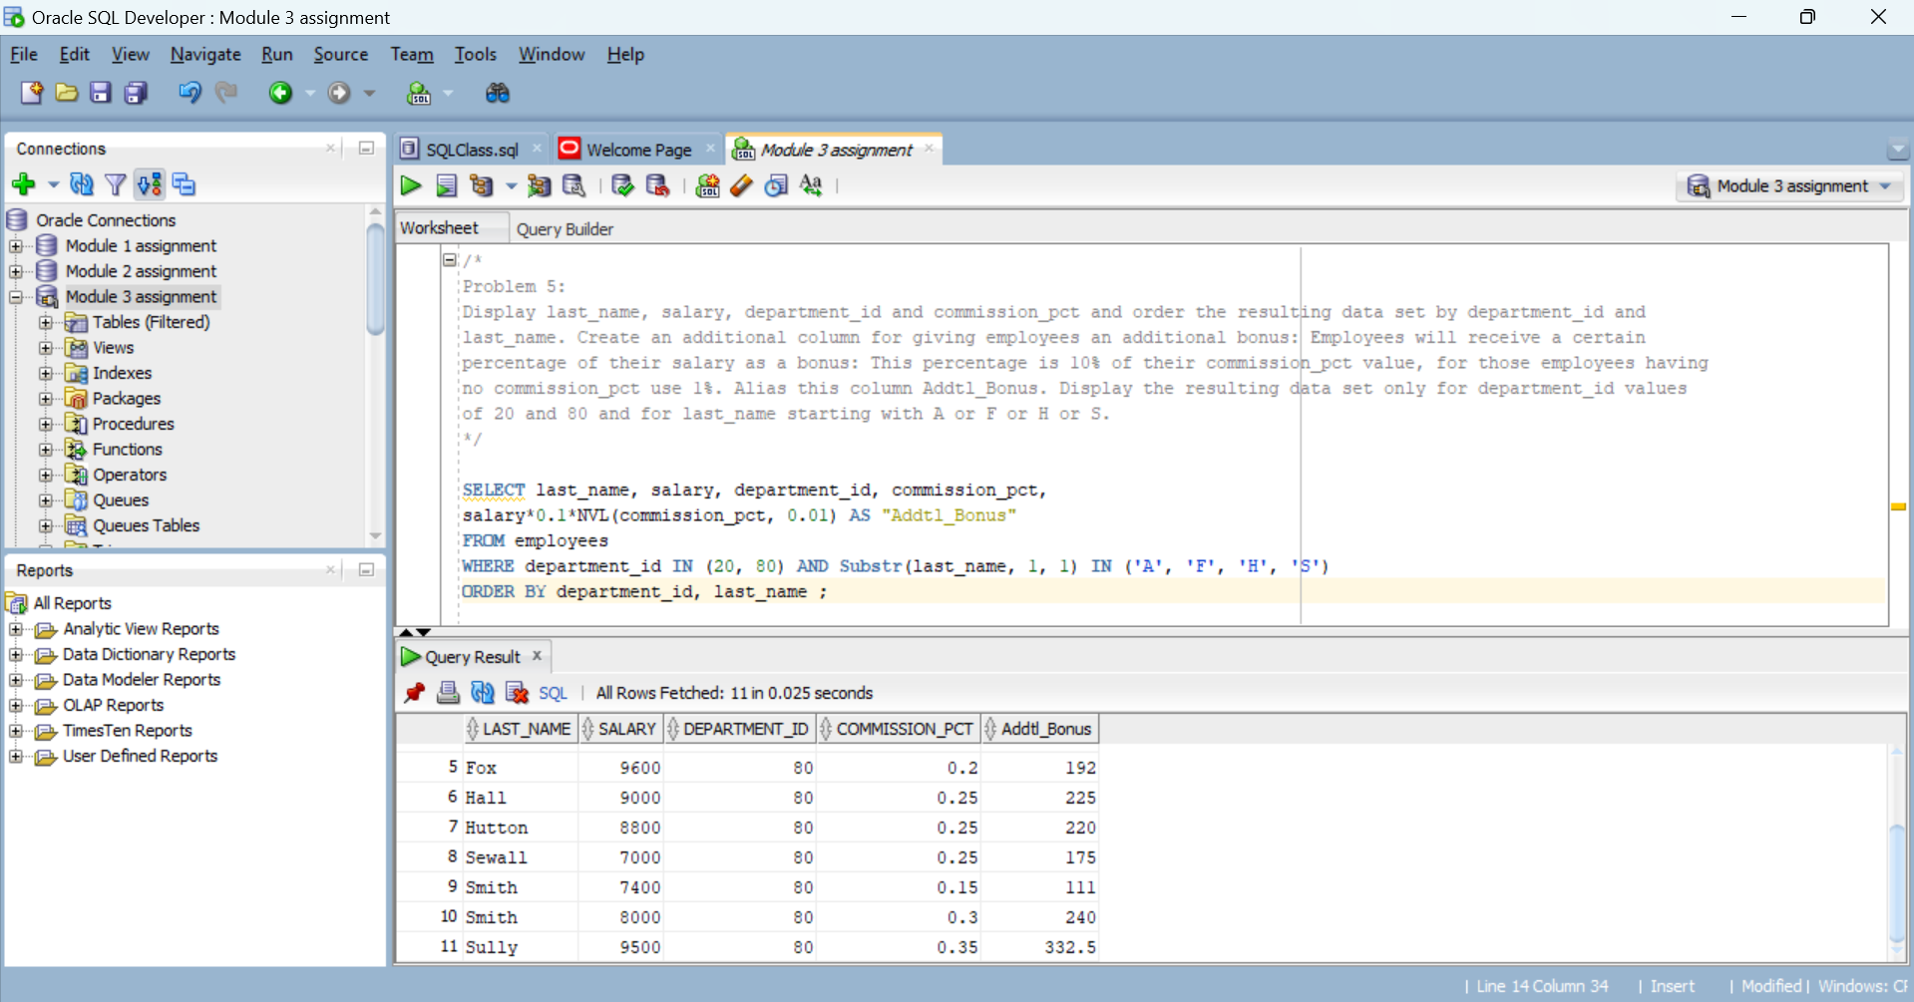

/*

**Problem 6:**

Create the following two SQL statements from table countries displaying only the country_name column:

Set 1: Countries starting with A, N, or I

Set 2: Countries from Europe (region_id=1)

Then create 3 queries performing the following SET operations (must use SET operators):

Show the countries that both sets have in common

Show the countries that exists in Set 1 but not in Set 2

Show all countries from both sets including duplicates

Deliverables: 5 queries

*/

1.

SELECT country_name

FROM countries

WHERE Substr(country_name, 1,1) IN ('A', 'N', 'I');

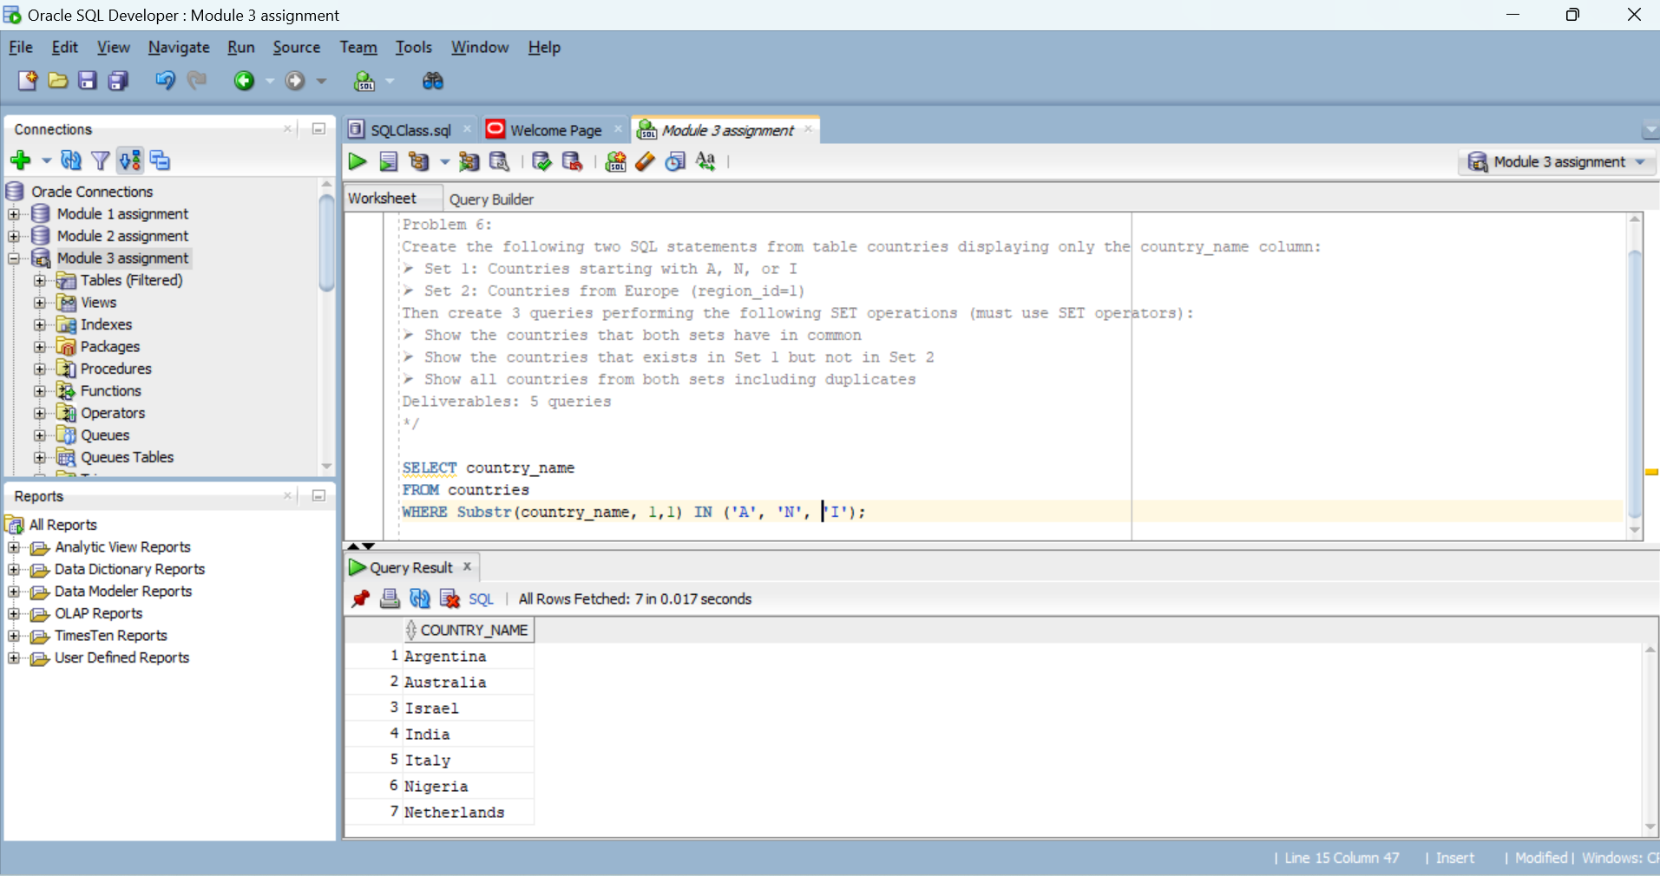

2.

SELECT country_name

FROM countries

WHERE region_id=1;

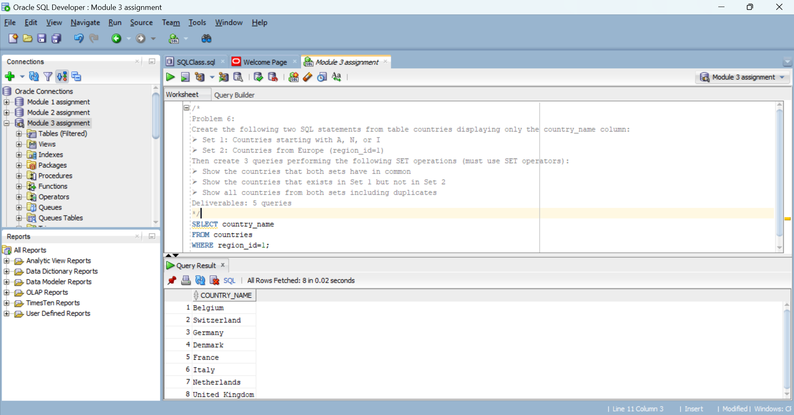

3.

SELECT country_name

FROM countries

Where Substr(country_name, 1,1) IN ('A', 'N', 'I')

INTERSECT

SELECT country_name

FROM countries

WHERE region_id=1;

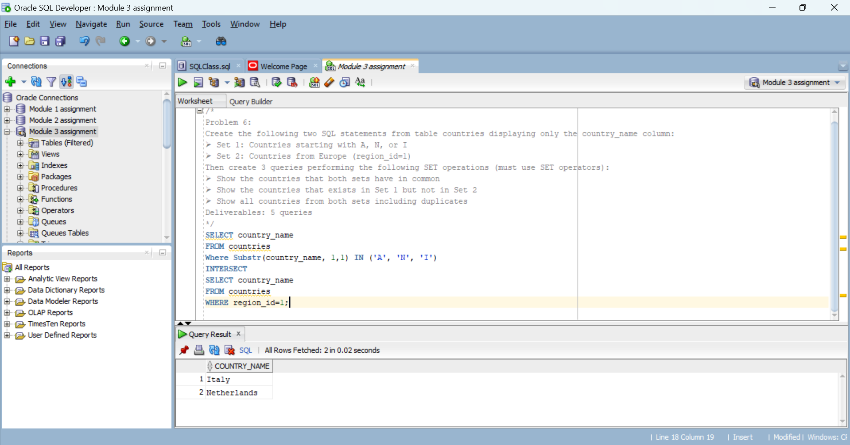

4.

SELECT country_name

FROM countries

Where Substr(country_name, 1,1) IN ('A', 'N', 'I')

MINUS

SELECT country_name

FROM countries

WHERE region_id=1;

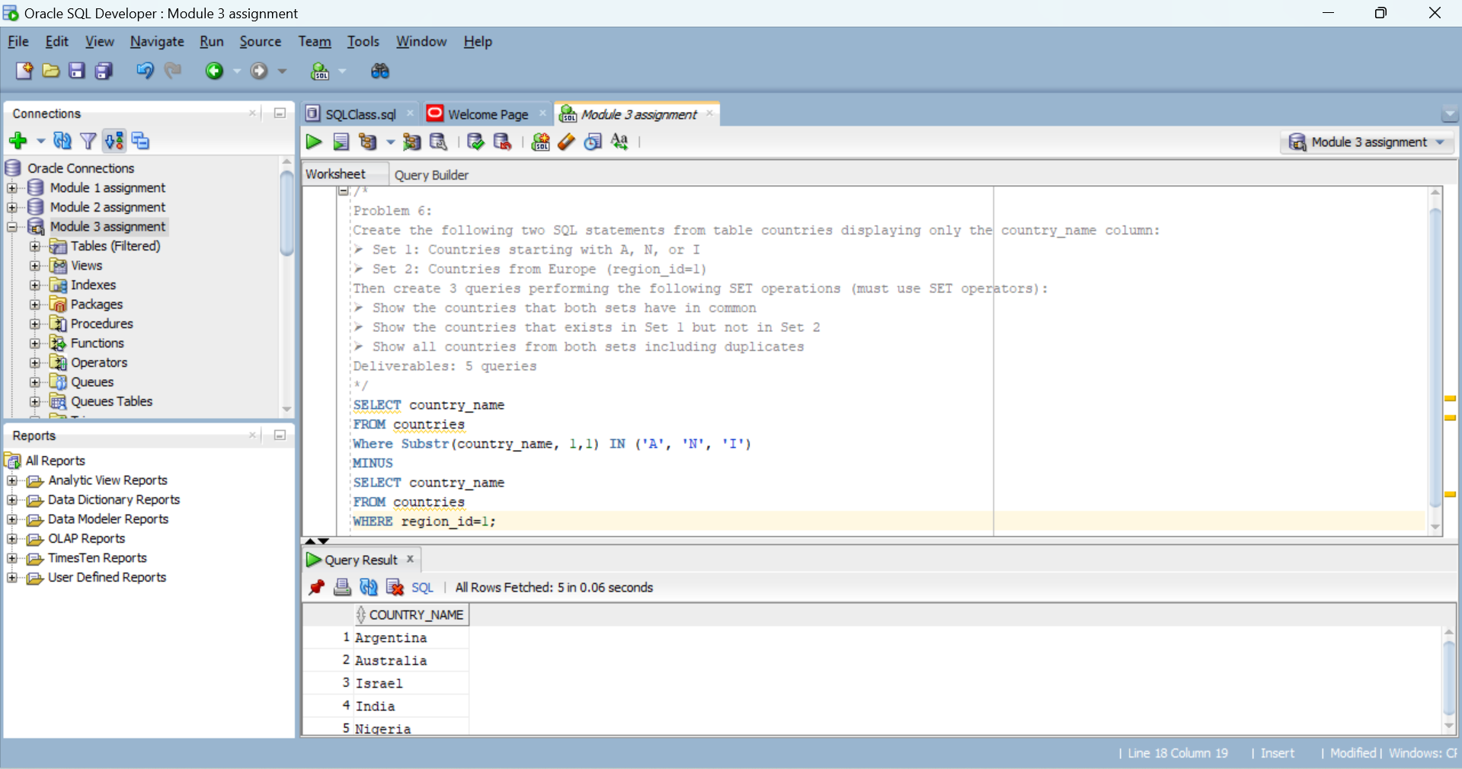

5.

SELECT country_name, 'table set 1' AS "Table_Name"

FROM countries

Where Substr(country_name, 1,1) IN ('A', 'N', 'I')

UNION ALL

SELECT country_name, 'table set 2'

FROM countries

WHERE region_id=1;

